**Write SQL commands for the queries given from a to f and write the output of the SQL commands given in part g based on a table Book shown below:**

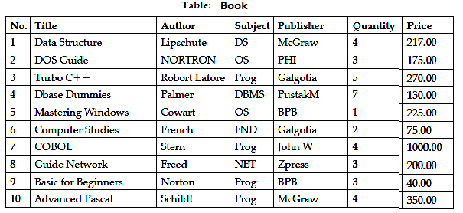

1 Write CREATE TABLE Script and INSERT STATEMENT for above data

2 Solve the following

(a) To display the title of all books with Price between 100 and 300.

(b) To display Title and Author of all the books having type Prog and published by BPB.

(c) To display the list of all the books with price more than 130 in ascending order of Qty.

(d) To display the list of all books whose quantity is less than 4.

(e) To display the publishers and the number of books of each book in the table.

(f) To insert a new book in the table LIBRARY.

(g) To increase the price of the book title ‘TURBO C++’ by Rs.30.

(h) To display the Title and Total Price of all Computer books. The Total Price is calculated as Price * Qty.

(i) Write the output of the following:

(i) Select MIN(Price) from Library;

(ii) Select Sum(Price * Qty) from Library where Qty > 3;

(iii) Select Avg(Price) from Library where Qty < 4;

(iv) Select Count(Distinct Publisher)

In the **book** table, add the columns quantity_issued with default value 0

**Table: student**

**We can have student_id also.**

|  |  |  |  |
| --- | --- | --- | --- |
| register_number | full_name | number_of_books_allowed | number_of_books_issued |
| S10110 | Rahul | 2 | 0 |
| S10120 | Stutee | 2 | 0 |
| S10130 | Logesh | 2 | 0 |
| S10140 | Ashish | 2 | 0 |

**Table: issue**

issue_id, issue_number, student_id, book_no, issue_date, return_date, fine_amount

And conduct below events

issue_book

return_book

The event issue_book allows the user to borrow book for reading. So quantity_issued will be incremented and number_of_books_issued have to be incremented.. At issue_book we have to capture the issue_date where return_date is null and fine_amount is 0.

Rule quantity_issued < quantity

number_of_books_issued < number_of_books_allowed

The event return_book allows the user to return the book after reading. quantity_issued will be incremented and number_of_books_issued have to be decremented. At return_book we have to update the return_date and fine_amount is calculated. fine_amount per late day is Rs20. If return_date is (issue_date + due_number_of_days - 1) is less than return_date there is no fine. Otherwise each extra day is the fine day and multiply Rs20 with number of late days to update into fine_amount.

Rule quantity_issued > 0

number_of_books_issued > 0